|  |
| --- |
| wDesign & Develop a system which could allow two or more parties to do a live interactive video session (like zoom). The system should let all parties do screen sharing as well as use webcam.   This will require the use of WebRTC. The recording produced can be mp4 or webm and ideally should be a single file containing screen sharing as well as webcam video of the session. |

**Understanding the Features:**

This Project contains some Feature related to Video Sharing. A Person can initiate a video sharing either it can be a cam sharing or screen sharing. It’s also had one exciting feature such as a person or a video initiator can record the video sharing and can download it in a webm or mpeg4 format.

Screen Sharing can be done between two people or in future it may be possible it can support more than 2 people.

**User Stories:**

As a User I want a screen sharing Web App So I can communicate with my team.

As a User I want to talk to my friend so I can communicate with them face to face.

As a User I want to Record My video sharing for future references.

As a User I want the Recorded video in the format of Mp4 and webm so I can easily run this recording anywhere.

**Use Case Diagram:**

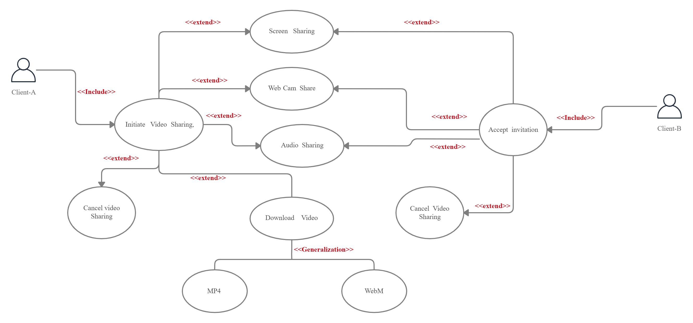

**Activity Diagram:**

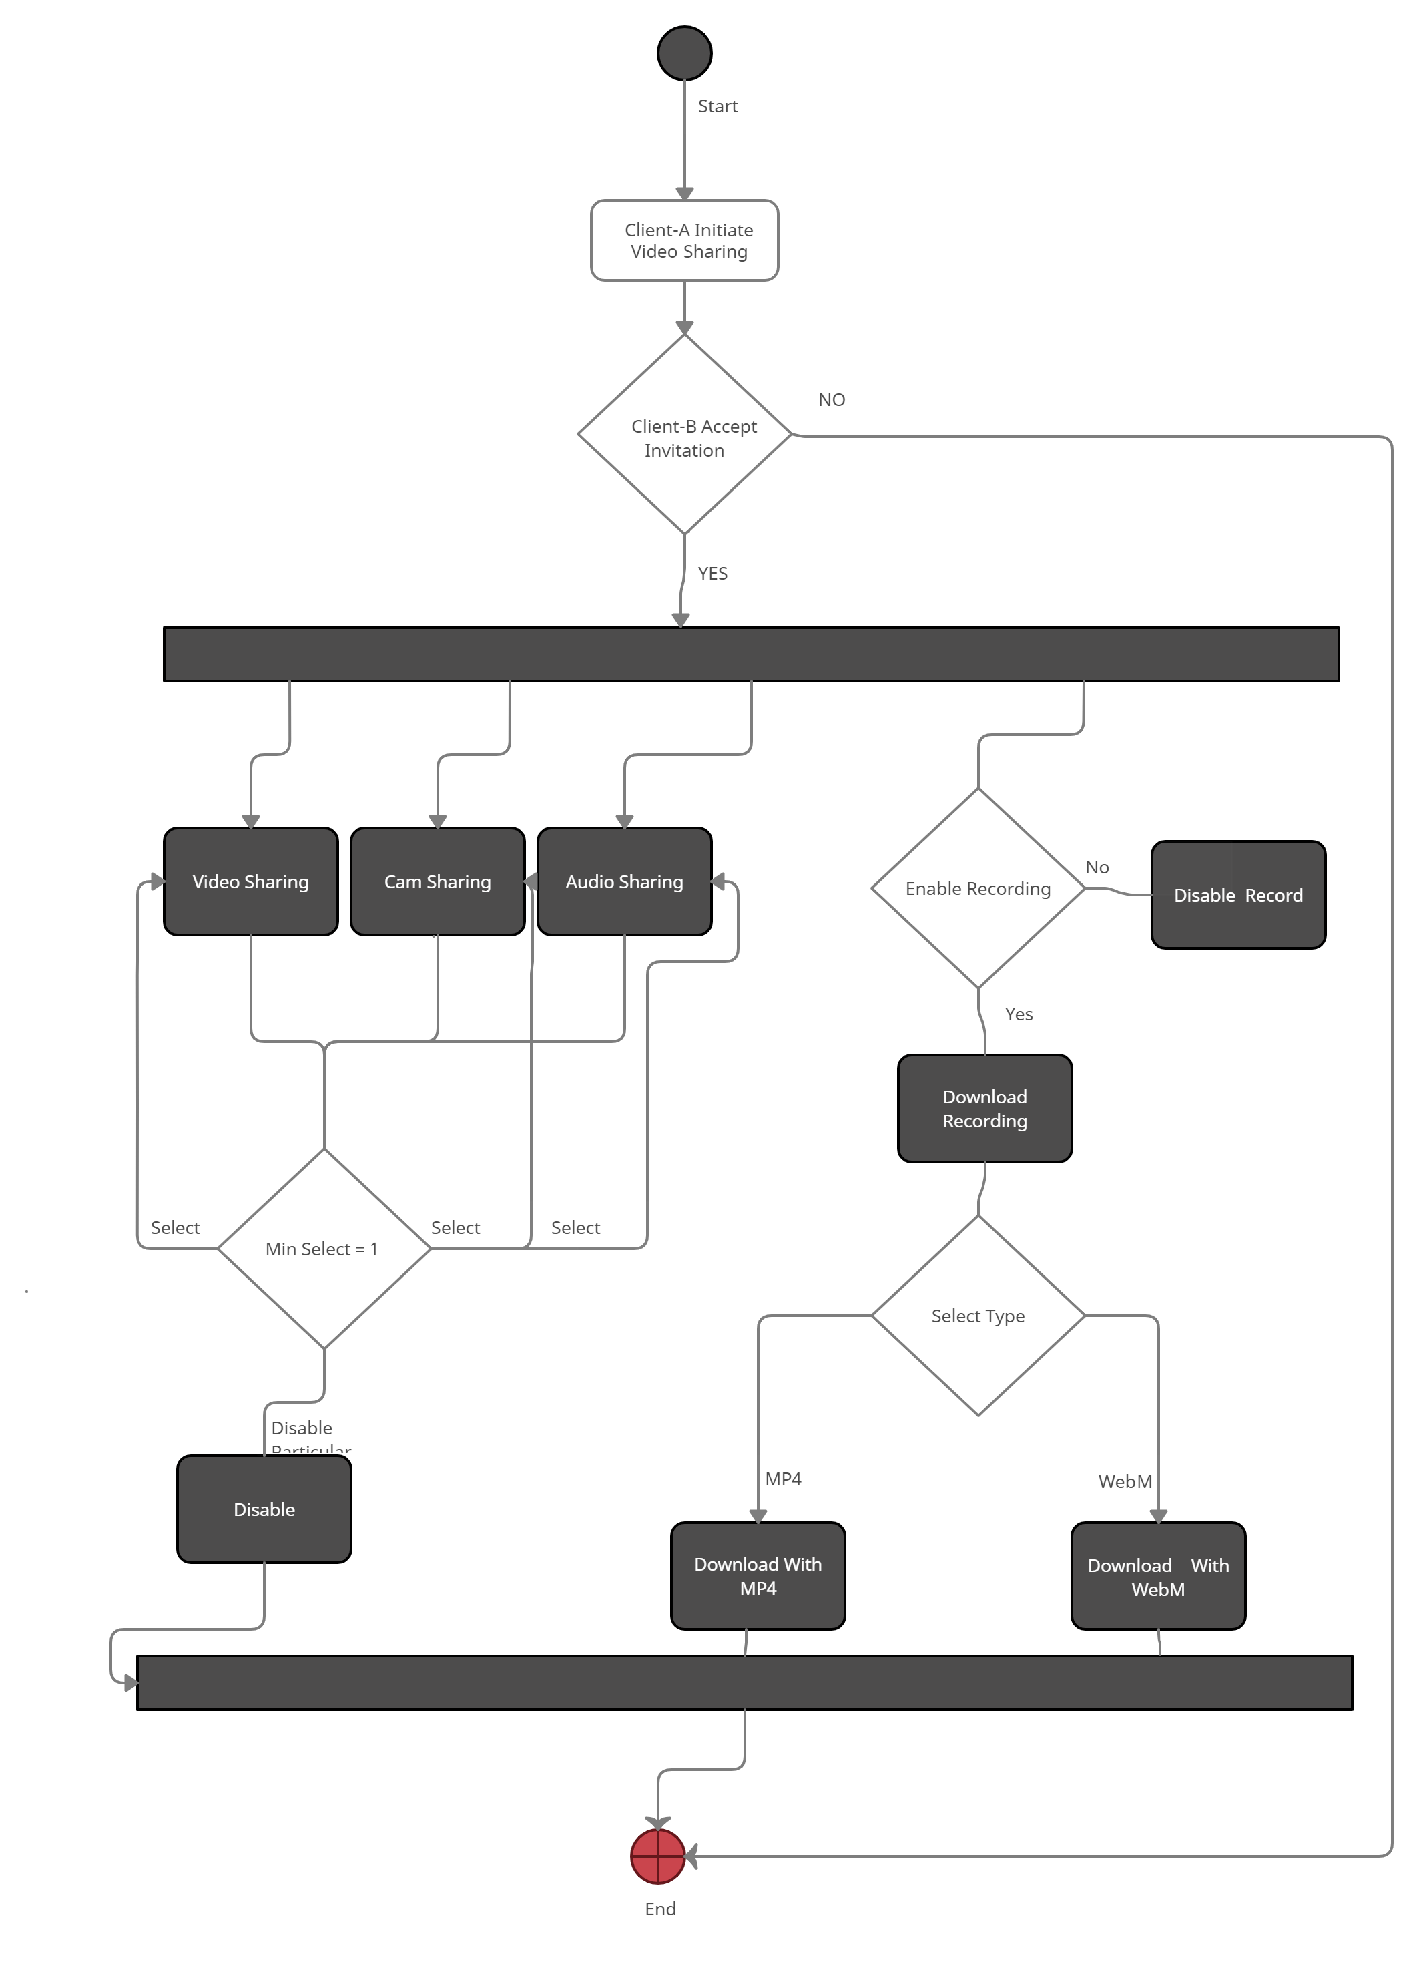

**Sequence Diagram:**

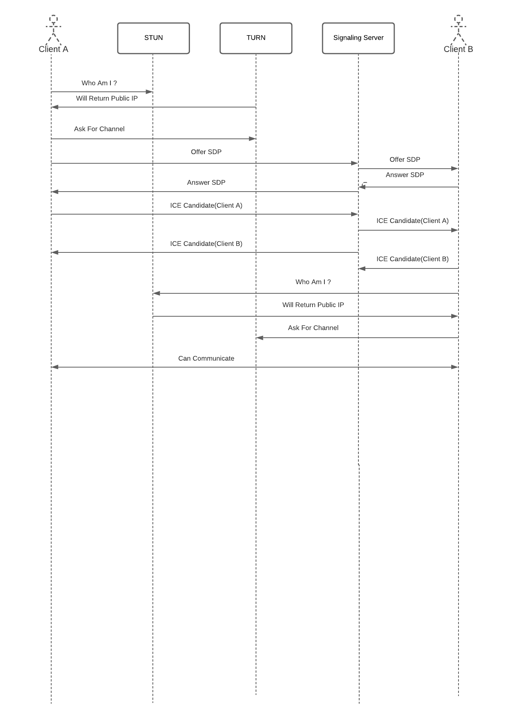

**Class Diagram:**

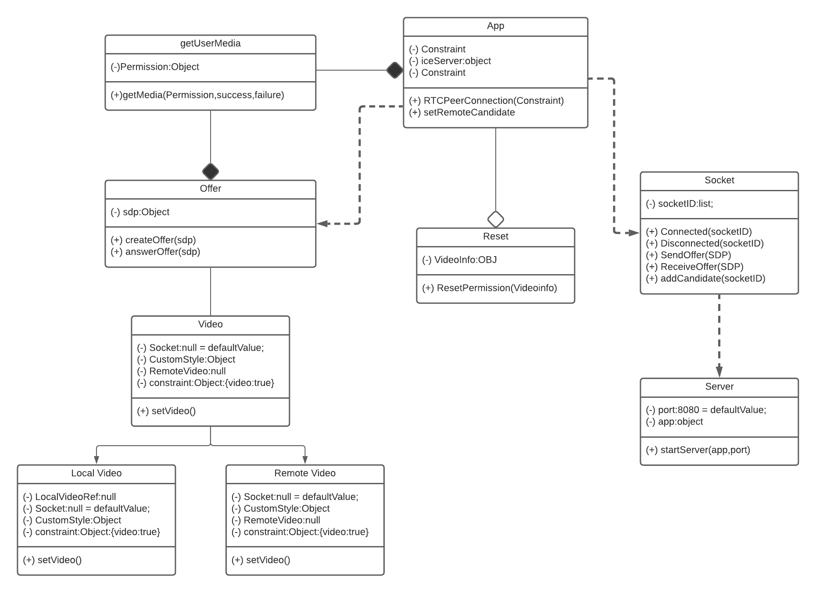

**Recommended Stack:**

This application can be made through any JavaScript web based related framework but as far as scope of the application is concerned, we can build that application in one of two ways first one is by using AngularJS and the second one is React JS. At the initial stage we will try to build this application in React JS after that if the application needs two-way Architecture we will try to make it in AngularJS.